Sachin Tendulkar surpassed Brian Lara’s total of 11953 Test runs in 2008 to become the highest run scorer in Test cricket history. Until his retirement in 2013, after an illustrious career featuring 200 Tests, Sachin accumulated 15921 Test runs. Many of his peers and those who followed him amassed Test runs, but none in a way that sparked the question, “Will they get close to Tendulkar’s tally?” There was some murmuring until 2018 when Sir Alastair Cook was still playing, but once he retired after 161 Tests at age 33, this record seemed unbeatable. Joseph Edward Root made his debut in 2012 in India, while Cook was still active, and began his career strongly.

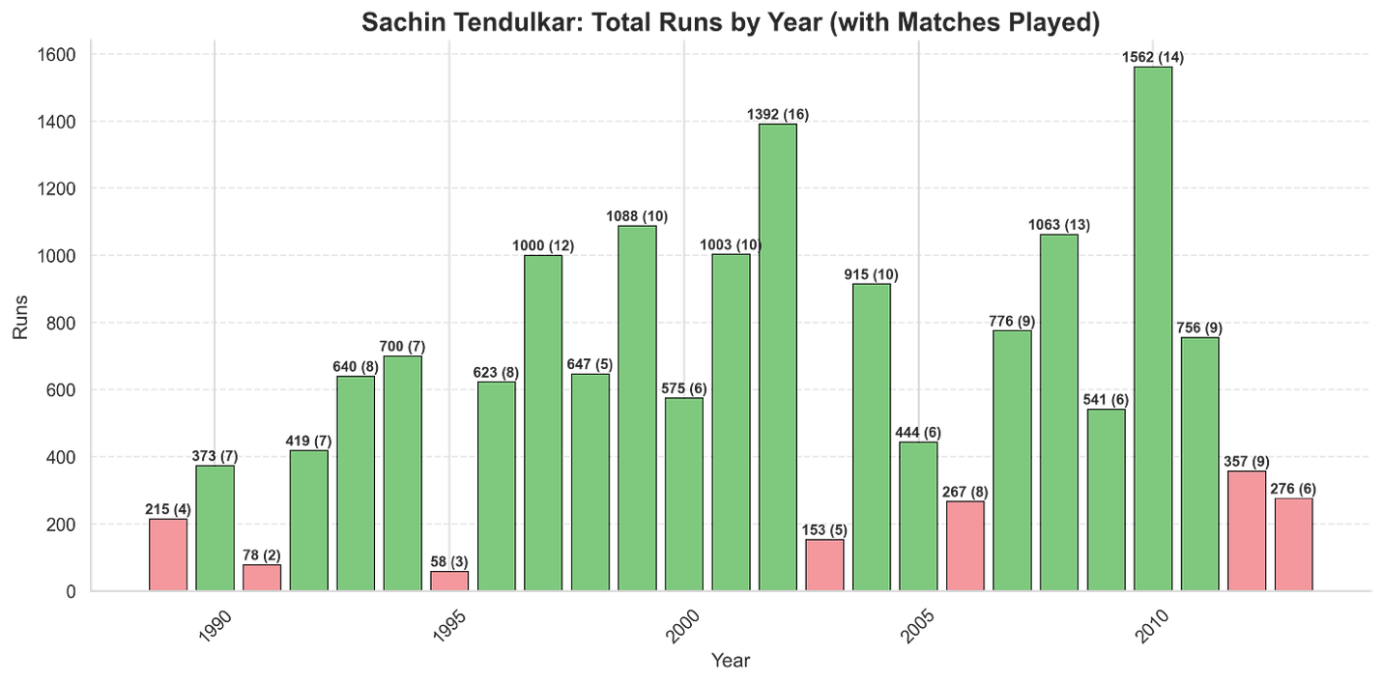

Root, who currently has 13543 runs at an average of 51 from 158 Tests, sits second in the pile of most Test runs scored. He overtook both Kallis and Ponting in the most recent Anderson-Tendulkar Trophy, where he scored 537 runs at an average of 67.12. He also added two centuries to his burgeoning tally of 100s. Over the last 13 years since 2012, we have seen the rise of Joe Root, and this Yorkshireman would be in contention to overhaul the Everest of Test Cricket runs. Will he, won’t he, time will tell. But for Root to even be in contention and to start provoking this question among cricket fans is a moment to relish.
Joe Root, without a doubt, is one of the finest batsmen England has ever produced, perhaps even the greatest English batsman. As conversations about Test cricket gradually give way to the glamour of T20s, this might be one of the last chances we have to reflect on this. It’s also likely to be the final time we hear the cliché, “Records are meant to be broken,” at least for this record.
No one has ever come so close and yet been far at the same time. Even as we are having this conversation, Root is still 2378 Test runs away and might be another two years away. But if it were to happen, you’d want the best seat in the house to watch it, and that’s why here I am.

What happens if Root continues to score at his present average?
If we were to extrapolate the number of innings Root needs to get to Tendulkar’s total runs, looking at his career average,

Joe Root’s career average = 51.29 (as of October 30th, 2025)
Runs required to get past Tendulkar = 15921 – 13543 = 2378 runs
Total Test required = 2378/ 51.29 46 Test innings around 23 Tests
This, however, is a simple abstraction dependent solely on his career average, which is highly variable year by year. To dig deeper, we have to look at England’s fixture over the next scheduled fixtures, and see if the scheduling and his averages against these teams give a better insight into answering the question at hand.
Currently, we have scheduled fixtures for England starting from December 2025 – the Ashes to December 2026. During this time, they play Australia away, and two home series against New Zealand and Pakistan.

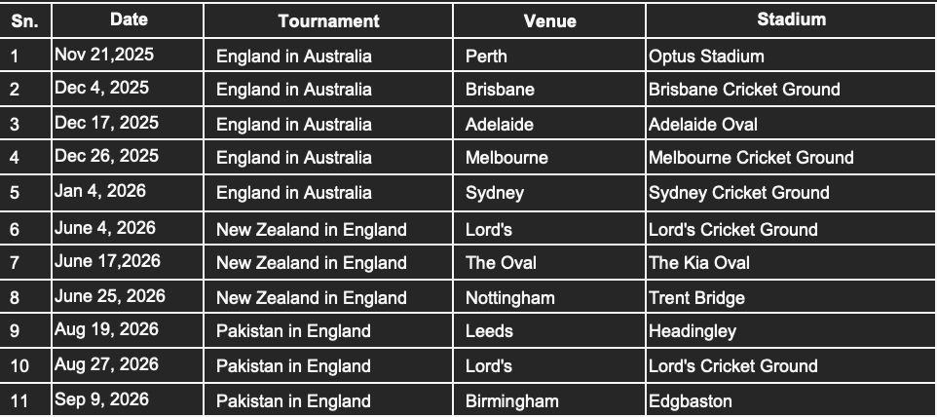

Before delving into the fixture-wise possibilities, given what an exceptional post-2020 Root has had, we will look at the scenarios before and after 2020.

Pre-2021 scenario
Before 2021, Root averaged 47.99, and twice averaged under 40 in a calendar year, once in 2019, and in 2013. He also had 12 hundred from 2012-2020, that is, on average, a bit more than century. If Root were to score the bulk of his runs in the remainder of the matches, at an average before 2021, then it would take him,
Total Test required = 2378/ 47.99 = about 49.55 innings = 25 Tests

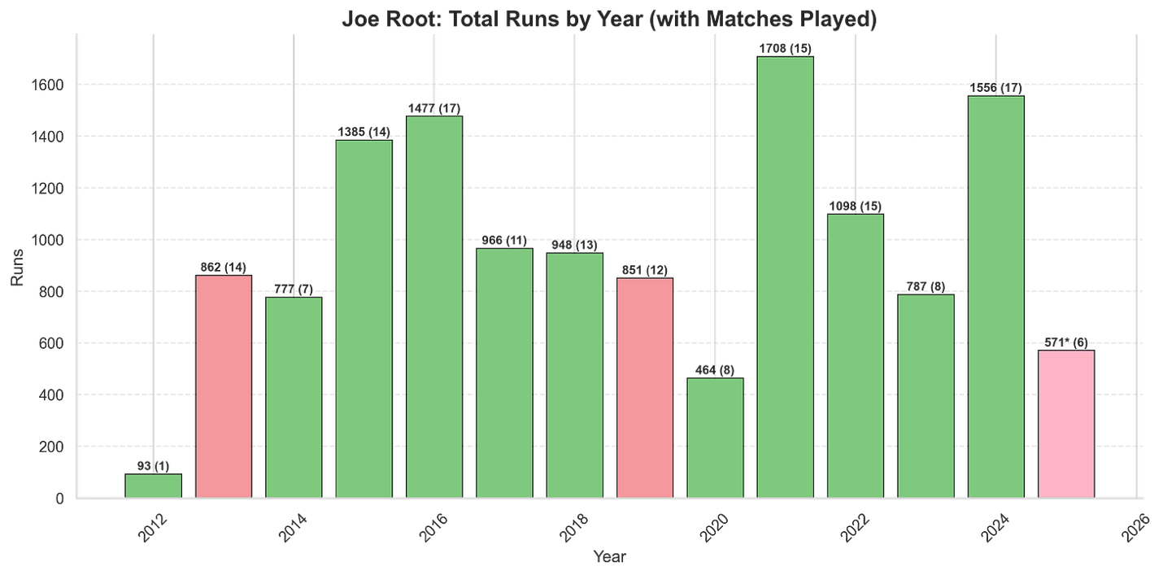

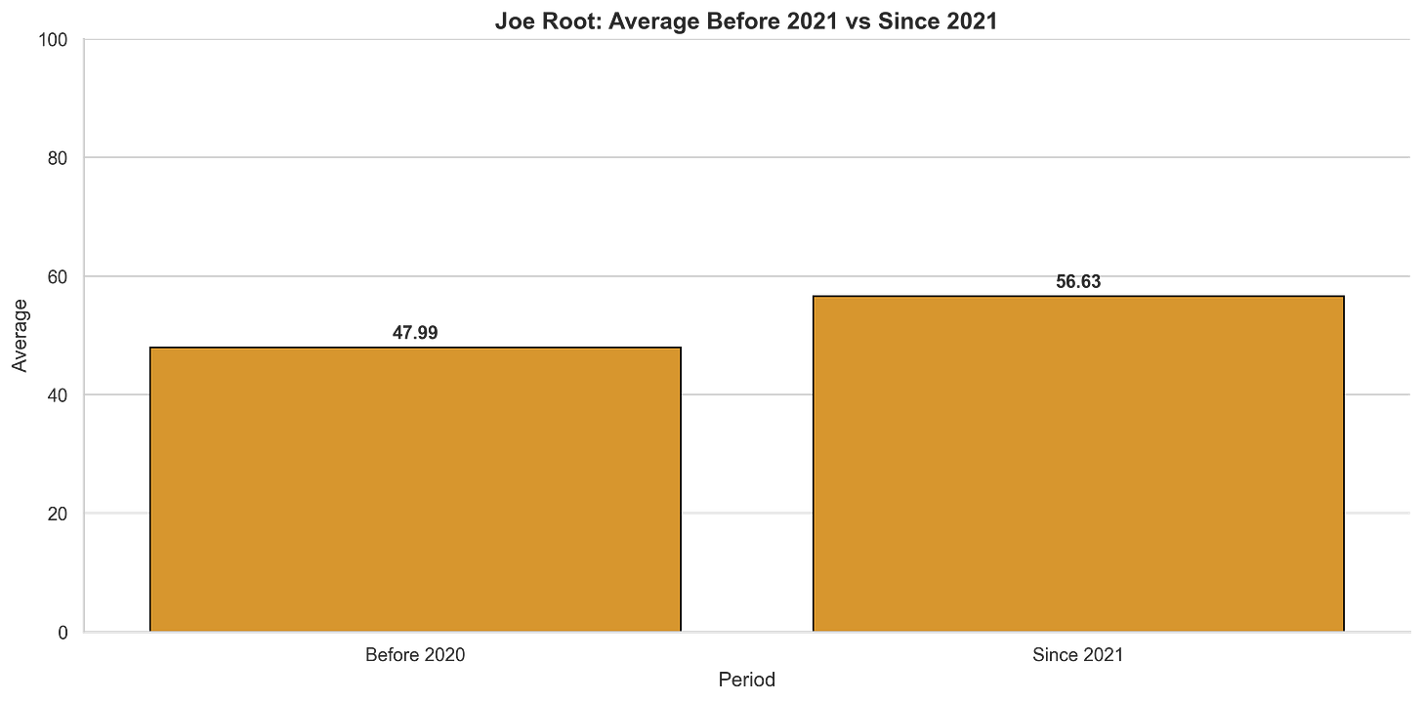

Post 2020 scenario:
Root has had a phenomenal last five years (2021-2025), averaging 56.63, and has scored 22 hundreds in this time. Before this, in his last 8 years from 2012-2020, he had 12 hundred, so he has been scoring a bit over 4 centuries a year, and his Test form is getting better. If we take his average from these years, the total Tests required to get past Tendulkar are:
Total Test required = 2378 / 56.63 = About 41.99 innings = 21 Tests
England are scheduled to play 11 of the Tests in 2025/26, whose fixtures are out, and they are scheduled to play 16 Tests until the end of April 2027 Cricinfo. So realistically, if Root is still playing, we should expect him to be ever so close to the top of the pile by which time he will be 37.

But, where is Root likely to end up at the end of 2026?
The fixtures till the end of 2026 have been set, and for the sake of the article, we remain optimistic that Root will play the 11 Tests until the September 2026 against Australia (away), and at home to New Zealand and Pakistan.
First up, there is the Ashes, and we can expect Root to play all five Tests.
Root travels to Australia for the Ashes in the twilight of his career and under a bit of pressure of having never scored a hundred here. But for all the talk about him not having a hundred here, he still averages a healthy 40.46 against the Australians overall, and 35.68 in 14 Tests in Australia.

Career average by opposition

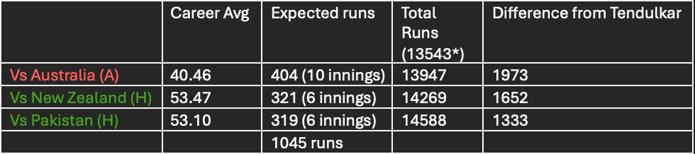

At this rate, at the end of the 2026 calendar year, Root will have another 1045 runs and will be 1333 runs away from Tendulkar’s total.

Career average by Country venue
The overall averages, though, miss the point that Root has scored his runs differently at home and away. If he were to score his as per his country-specific average, then -

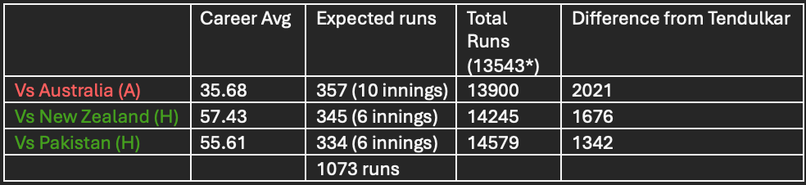

While Root averages less than 40 in Australia and below his career average against Australia, he does average higher against both New Zealand and Pakistan at home. He will be 1342 runs behind Tendulkar’s tally by the end of 2026 if he scores at his usual rate against these teams.
With 16 Tests scheduled until April 2027, of which 11 are accounted for by September 2026, if Root scores at his career average in the remaining 5 Tests,
The calculation is: 5 x 51.69 = 258.45, approximately 258 runs.
This would add roughly 258 runs to his total of either 14579 or 14588, depending on his scoring rate against different opponents and countries, putting him 1000 runs shy of Tendulkar.
Will he reach that mark or not? Only time will tell. For now, we wait to see what this modern master accomplishes in the sport’s pinnacle – Test cricket. I, for one, am rooting for a nail-biting finish, and if it comes down to that, this individual rivalry will be a story for the ages.

